3. (25p) Answer all the questions on an electronic document. This exercise computes the frequency response of a canceller that can be used in a MTI system by using Gaussian white noise as input and following the same time-domain procedure that we did in exercises 7.2 and 7.3. Consider a canceller like the one in the figure:

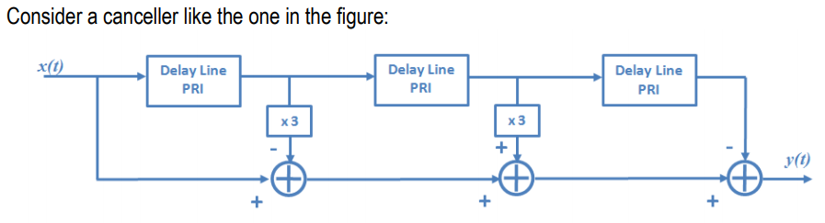

Then:

a) Plot the power density spectrum (linear scale) of the canceller output y when the input x is a Gaussian white noise vector having zero mean and 1 W (length: 20 000 samples). What is the length of the resulting vector? (There is no need to correctly label the frequency axis of the plot. Normalize the plot in order to have the maximum at 1).

The length is 19997 or 20000-3.

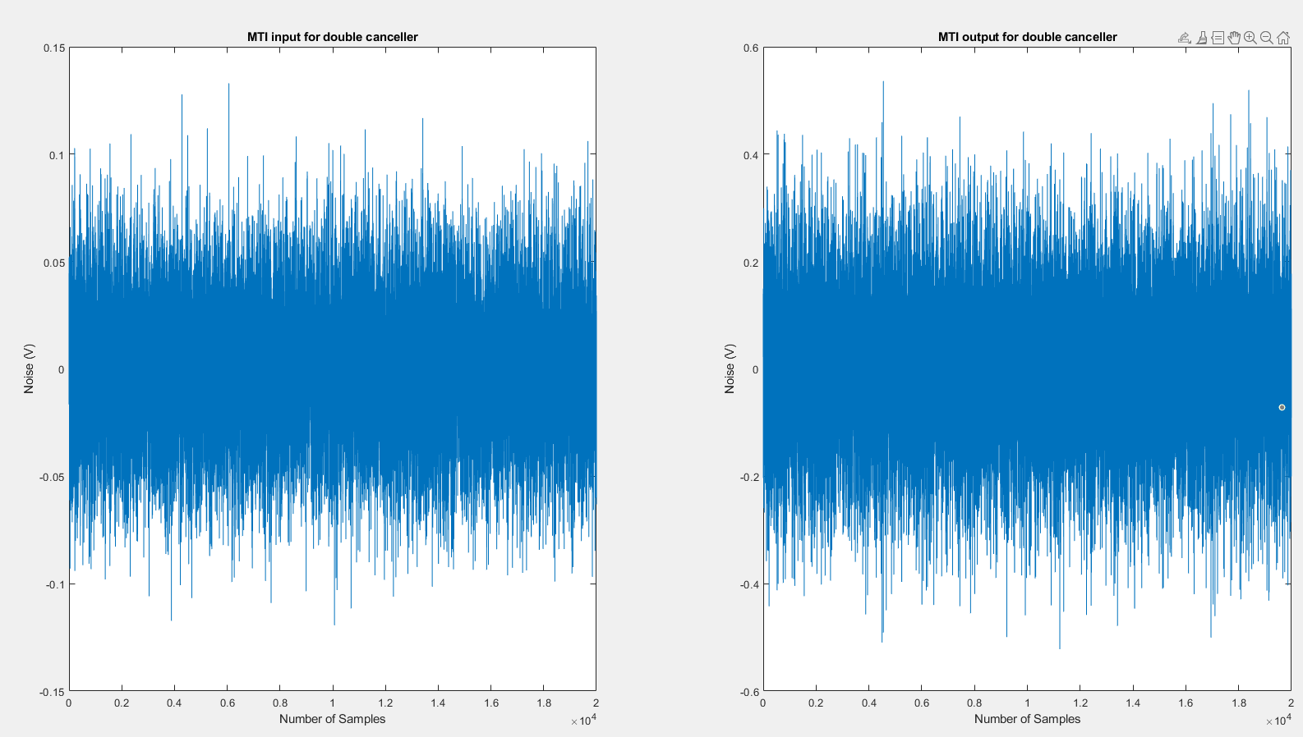

If we normalize it will be

b) Make a plot of the averaged power density spectrum when 2000 realizations of the previous result are carried out. (There is no need to correctly label the frequency axis of the plot. Normalize the plot in order to have the maximum at 1).

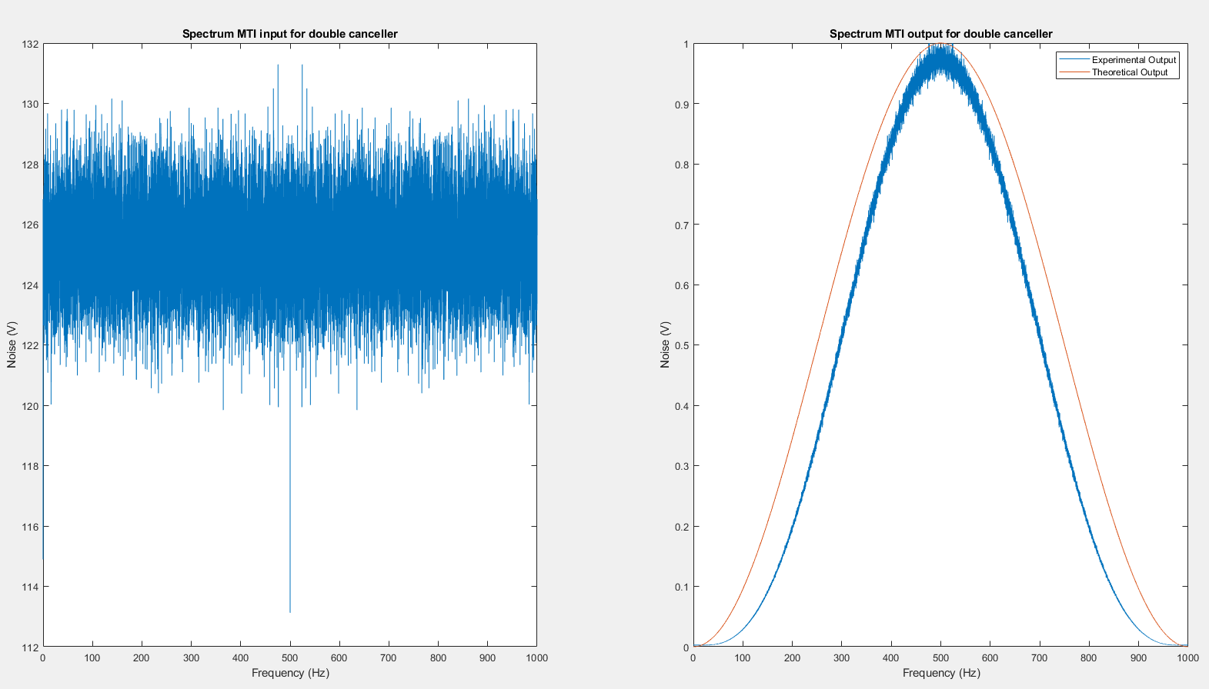

After normalization it becomes